DRAFT ZONAL DEVELOP0MENT PLAN OF NARELA SUBCITY ZONES- M, N & P (Part)

1.0 INTRODUCTION
As per the Master Plan of Delhi 2001 notified by the Central Govt. under the Delhi Development Act, 1957 on 1.8.1990, the National Capital Territory of Delhi is divided into 15 zones, out of which 8 zones (A-H) are in Urban Delhi, 6 zones (H-N & P) are in urban extn./rural areas. Zone –O is for River Yamuna (River Front Area). A zone could be divided into sub zones.

1.1 Narela subcity mainly comprises of parts or zone – M,N & P and forms part of the phase IIB & III of the urban extension plan approved by the Authority vide resolution no. 79 dt. 30.6.1987 as part of Master Plan Delhi-2001.

1.2 This zonal plan for part of zones M, N & P (Narela subcity) is for the area envisaged for the development as per urban extension plan considered and approved by the Authority.

1.3 Hereinafter this zonal plan is referred to as Zonal Plan for Narela subcity.

2.0 STATUTORY PROVISIONS
  - As per MPD 2001, a Zonal Development Plan means a plan for a zone (Division) of the union territory of Delhi. The Zonal Plan (Divisional Plan) details out the policy of the Master Plan And Acts as a link between the layout plan and the Master Plan. The Development Schemes/Layout Plan indicating use premises should confirm to the Master plan/Zonal (Divisional) Plan.
2.2 MPD –2001 stipulates that already approved sub-zonal plans in conformity with master plan shall continue to be operative, The proposed zonal plans after approval should supercede earlier approved sub-zonal plans.
2.3 Section –8 of Delhi Development Act Provides for preparation of Zonal Development plan simultaneously with the preparation of master plan or as soon as may be, the authority shall proceed with the preparation of Zonal Development Plan for each of the zone into which Delhi may be divided. However, a Zonal Development Plan may contain a site plan and land use plan with approximate location and extent of land uses such as public and semi- public building/works centers, utilities, roads, housing recreation, industries, business, market, schools, hospitals, open spaces etc. it may also specify standards of population, density and various component of development of the zones.
The procedure to be followed for the preparation and approval of the Zonal Development Plan is laid down in Section 10 of the Act.
2.4 The zonal-plan of the area has been formulated under Sections ‘8’ and will be processed under section ‘10’ of the D.D. Act 1957

3.0 LOCATION, BOUNDARIES AND AREA
3.1 Narela subcity is located on the west of G.T. Karnal Road (NH-!) and spreads over in 3 planning divisions i.e. part of zone M, Part of Zone N and part of zone-P.
3.2 Following are the Boundaries
North : NCTD Boundary
South : Boundaries of Sub Zones C-21 & H-19
East : G. T. Karnal Road & its Bypass (NH-I)
West : Western Yamuna Canal

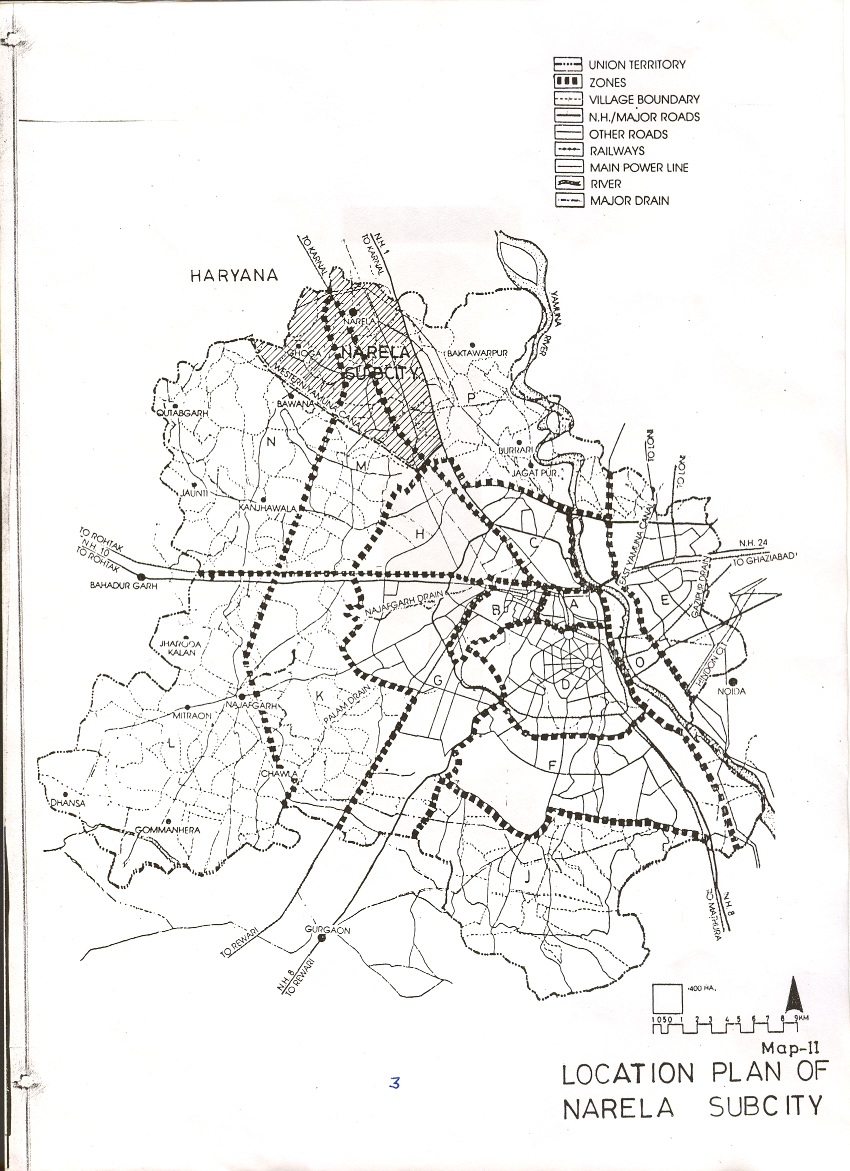
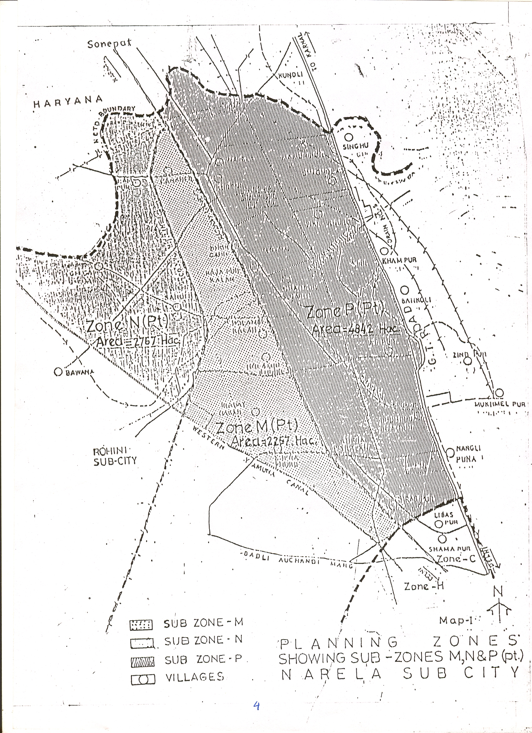
3.3 The total area of Narela subcity is about 9866 Hact. with the following breakup:
Area under part Zone M : 2257 ha.
Area under part Zone N : 2767 ha.
Area under part Zone P : 4842 ha.

4.0 POPULATION AND WORK FORCE
4.1 POPULATION- As per MPD-2021 the urban extension areas are proposed to be planned with an overall gross density ranging from 160 to 200 persons per hectare and based on the area under consideration the proposed population computes to 1.2 million including that of existing settlements.

4.2 WORK FORCE – MPD-2001 has anticipated a participation rate of 42% and thereby the work force in the Naela subcity works out to about 0.32 million, due to the location of industries in the subcity, the component of work force works out to be roughly 35-40% i.e. in all a generation of 0.4 million workers.

5.0 PLAN PROVISION
5.1 Master Plan for Delhi-1962
The MPD –62 has recommend to develop Narela as one of the ring towns around Delhi Metropolitan Area (DMA) owing to its location and development potential. It proposed a township for 60,000 people with government offices and industry to make the town a self contained unit. The proposal included the adjoining developments of Mamurpur village and the development undertaken by the Ministry of Rehabilitation. Broadly the landuse plan for 1753 acres was detailed out with a gross residential density of 50-60 persons/acre. However, it also mentioned that “the proposals with respect to Narela are only indicative and not mandatory.” As per the provisions of MPD-62 a zonal development plan for Narela ring town/settlement (zone I-1) was prepared and approved by the Central Govt. Ministry of Works and Housing vide letter no.11-2/69-UDI dated 10th January 1974.

5.2 Master Plan for Delhi –2001
To accommodate the balance 3.1 million population the DUA 81, which could systematically hold 82 lakh population, approximately needs to be extended by about 18,000 to 24000 ha. over the next two decades to effectively respond to the growth of the capital. Land required for various development in the extended time frame by the year 2001 may be acquired from time to time, with due regard to the balance development of the city. In the plan, 1,000 hectares (approx.) have been added to DUA-81 urban limits, thus the balance requirement would be of the order of about 14,000 to 20,000 ha. During the preparation of the plans of urban extension Najafgarh, Narela and other important settlements in rural use zone like Nangloi, Bawana and Alipur shall be provided with infrastructure and integrated in the Urban Extension Plan.
The land in the urban extension (UE) would approximately be distributed under different landuses in the following manner:

Table 1 : Proposed landuse distribution in Urban Extension
S. No. | Landuse | %age of land
1 | Residential | 45-55
2. | Commercial | 3-4
3 | Industrial | 6-7
4 | Recreational | 15-20
5 | Public & semi-public facilities | 8-10
6 | Circulation | 10-12

Further few specific proposal have been outlined by the MPD-2001 to be accommodated in urban extension in North which are as follows:
- Integrated Freight Complex
“For the integration of goods movement by road and rail, freight complexes have been recommended. These would consist of wholesale markets, warehousing, road (truck) and rail transport terminals so as to curtail the movement of heavy vehicles within the developments.
The freight complexes are to be located in the places where they intercept the maximum possible regional goods traffic entering Delhi. Keeping this in view, the four sites for freight complexes are – Madanpur Khaddar (NH-2), Patparganj (NH-24), G.T. Road (NH1) and Bharthal (NH-8)”.
The IFC proposed in Narela would be occupying the area 397-81 ha. Among the various uses, it would be constituting the wholesale, warehousing, freight terminal, truck terminal and distt. Centre. It was approved by TC, DDA dt. 6.2.1996.
- Inter City Passenger Movement
To cater to the city passenger movement in Delhi, which has been growing at about 4% per annum, two nos. of metropolitan passenger terminals, are proposed which would also serve the DMA.

  - Urban Extension Plan Provisions
The DDA approved the urban extension plan on 30.6.1987 vide resolution no.79 which proposed the phasing of the plan based on the population projections given below:

Table 2: Population Projections
Population projection by | Population Urban 2001 (million) | Population accommodation in DUA 81 (million) | Balance (million) | Land need (Hectares)
NCR | 11.0 | 8.2 | 2.8 | 18,000
DDA | 12.2 | 8.2 | 4.0 | 24,000
As per existing trend | 14.4 | 8.2 | 6.2 | 35,000
Source :- Extensive Modification in MPD-2001, Agenda Dated 30.06.1987, DDA.
The Urban Extension could be restricted upto phase II if the population of Delhi could be restricted to 11 million by 2001. In case of 12.2 million population by 2001, the urban extension would be upto phase III and in case 14.4 million population by 2001, the urban extension would be upto phase-IV. As already mentioned Narela subcity forms a part of Phase IIB and III of this urban extension plan.
5.4 NCR Plan Provision
the statutory board for NCR which was set up in 1985 prepared the first statutory Regional Plan-2001 which is in operation at present. The NCR region extends over an area of 34,242 square km., in the four states of Haryana, Rajasthan, Uttar Pradesh and National Capital Territory of Delhi. The relevant recommendations are as under:
- The NCR plan has identified 9 major corridors in transport network system with the prime objective of controlling growth of Delhi, Narela subcity area falls on one of these corridors i.e. Sonepat-Panipat corridor.
- The plan has suggested provision of 100 mtr green belt along the National Highways and expressways and 60 mtr.
- Along the State highways, further large area under green belt has been reserved which extends from proposed 100 mtr. Expressway in the Urban Extension Plan 2001 upto the NCT of Delhi to act as buffer zone between the urbanisable areas of urban extension proposed in Delhi and DMA town of Kondli, Haryana.

6.0 EXISTING PROFILE
  - As per the provisions of MPD-62, the Zonal Plan of Narela area stands approved by the Government and is known as Zone I-1. The salient features of the Zonal Plan of zone I-1 are as under:
The zonal plan in its proposals stressed on the need for redevelopment of the existing Mandi apart from providing a community centre, police station, a hospital and a college site. The proposal incorporated a green agricultural belt in order to limit the growth of township from primitive urban growth and haphazard development during the plan period. The break-up of major landuses in two phases annexed at Annexure-1.
The township was planned for 1.05 lakh at an overall density of 55 persons per acre. The town has been divided into two parts i.e. Phase I and Phase II. The gross density varying from 100-150 persons per acre has been provided in zones in relation to the landuse i.e. a density of 150 P.P. acres has been proposed near work centres and density of 100 P.P. acres towards the outskirts of the town. In all a total of 841 acres was proposed for residential development. An industrial area of 534 acres proposed to generate employment for 16,000 industrial workers.

6.2 Physical Characteristics
The location of the proposed sub-city is on a terrain, which is ideally suited for urban development. The entire subcity is very well connected with the mothercity as well as the adjoining state of Haryana. The railway line which is running almost through the middle of the area divides the subcity into two major zones.
The entire sub-city area is a vast expanse of more or less flat terrain with land gradually slopping towards the south. The area has very large green tree coverage in the form of orchards, forest (declared as reserved forest) and farmlands. The subcity area has good soil for construction. The whole of subcity has good natural drainage system and the area is divided into two drainage basins (I) catchment of Bawana escape and (ii) catchment of Drain No. 6. Both these drains have number of subsidiaries spread over the entire subcity area holding mainly the rural discharge.

6.3 Existing Development:
Urban villages – Development of village shall be integrated part of the development scheme of the area. Around this settlement, educational, health and recreational facilities and work area would be developed for the benefit of the village population in urban as well as rural Delhi.
The significant existing developments in the subcity are as under:
- The abadis of 16 village, and two towns Alipur and Narela fall in the subcity. A list of villages falling in Narela subcity with their population as per census of India 1991. Is annexed as Annexure II.
- The large number of farm houses are existing in this area. A number of unauthorized colonies / construction have also grown organically along the major rural roads within the subcity area.
- The major portion of planned development taken up by DDA is near the Narela Urban Area where roughly 516 ha. of land has been acquired and is in process of development under various uses.
- DSIDC has acquired and developed 247 ha of land.
- Land for utilities like water treatment plant, road, ESS, part integrated freight complex has been acquired and are being developed.
- There are a number of godowns and industries. Some of these industries do not conform to MPD-2001 provision and have been ordered to be closed down by the Supreme Court of India (List of pollutant Industries is at Annexure IV)

7.0 FRAMEWORK FOR THE PREPARATION OF ZONAL DEVELOPMENT PLAN:
In addition to the provision given in the Delhi Development Act and MPD-2001 with regard to the preparation of the zonal development plans, other broad objectives of the zonal development plan are as under:
i) To incorporate the Zonal Development Plan for Zone I-1 prepared as per MPD-62.
ii) To broadly accommodate the landuses as envisaged in the Urban Extension Plan-2001.
iii) To retain the major circulation system as envisaged in the Urban Extension Plan.
iv) To retain the agriculture green belt in between the proposed urban development and the National Capital Territory of Delhi.

8.0 LANDUSE PLAN
8.1 The land use plan of the subcity is based within the frame-work of urban extension plan, its existing and proposed circulation system and the different residential density pattern to be followed for the various residential pockets. The MRTS corridor identified along the existing rail corridor connected with Narela, upto Holambi Kalan, is envisaged to be a high-density zone. Following is the land use breaks-up of Narela at subcity level:
Total area : 9866 Ha
Area under agriculture green belt : 2501 Ha
Proposed unbanisable area : 7365 Ha

Table 3 : Landuse breakup for Urbanisable Area, Narela subcity
Landuse | Area (Ha) | %age
Residential | 3,165 | 42.9
Commercial | 566 | 7.7
Public & Semi-Public | 875 | 11.9
Manufacturing | 308 | 4.1
Utility | 327 | 4.5
Government | 16 | 0.2
Recreational | 1,029 | 14.0
Transportation | 1,079 | 14.7
Total | 7,365 | 100.0

  - Residential Development and Housing Areas
The subcity when fully developed will provide housing opportunities to over 2.7 lakh families of all income groups. It is proposed to have differential residential densities with rail line identified as the major high density corridor. The development of residential areas will provide for housing in public, cooperative and private sector. Special emphasis will be given in reserving the areas for the resettlement of squatters. The types of housing in Narela would be
- cooperative housing societies
- DDA Housing for its registrants in form of built up flats, expandable housing.
- Janta housing in terms of one room tenements.
- Institutional housing for employees of various government organisations.
- Resettlement of squatters
- Plots for alternative allotments/auction.
The village abadi areas, unauthorised colonies would be dealt with as per statutory provisions and policy decisions taken from time to time while working out detailed plans.

  - Commercial
The sites for four district centres and twelve community centres as per the MPD-2001 have been shown in the landuse plan. Community centres to be planned in future will also have a component of service centre suitably identified at the time of detailed planning to take care of such permissible activities at sector level. Similarly, the sites for Integrated Freight Complex etc. have been shown in the landuse plan.

  - Petrol pumps & Gas Godowns
As per Master Plan standards a total no. of 54 petrol pumps/
Service stations as per details given below (Table 4) are required:

Table 4: Petrol Pumps/service stations required as per MPD-2001
S.No. | Standard | Petrol pumps required
1 | One petrol pump per 150 ha. of gross residential area; 3165 ha. | 21
2 | One petrol pump per 40 ha. of gross residential area; 308 ha. | 8
3 | Two petrol pumps in each Freight complex | 2
4 | Two petrol pumps in each District Centre (4 nos) | 8
5 | One petrol pump (only filling station) in each community centre | 12
6 | District level population | 3
 | Total | 54

The total no. of 30 gas godowns are required at the rate of one gas godown for 40,000 population. Both the petrol pump sites and gas godowns sites will be suitably located in the use zones as per MPD-2001.
  - Public and semi-public facilities
The requirement of public and semi-public facilities (social infrastructure) upto the divisional level (Zonal Plan Level) have been identified and located in 21 pockets in the subcity plan as per the norms given in MPD-2001. Each public and semi-public facility pocket is a cluster of various master plan facilities worked out as per the population of the sub-zonal pockets (Details given at annexure-IIIA & IIIB)
  - Manufacturing
The total area of 308 ha is identified for manufacturing use zone out of which 247 ha has already been developed by DSIDC and is operational. In the new industrial areas, industries as per provisions of MPD-2001 will be allowed to be set up and part of the industrial areas would be used for re-locating the non-conforming industries from the city of Delhi. The existing polluting industries (Annexure IV) as well as those, which are not conforming to the provision of the Master Plan, would be dealt with according to the decision taken from time by the concerned agencies.
8.7 Utilities / Physical Infrastructure
Component | Remarks
Water Supply | The total water requirement of the subcity works out to be approximately 120 MGD @ 80 gallons per day. Water treatment Plants with a capacity of 300 MGD has been planned which would serve Rohini as well. The water supply system will consist of underground reservoirs / command tanks (for 1.5 to 2 lac populations) inter connected by water mains. Each Command Tank will have its own command area. About 8 command tanks have been located. Land for W.T.P. along Western Yamuna canal has been acquired and is in the process of development by D.J.B.
Sewerage system | Total sewerage expected to be generated is 90 MGD. Two STPs have been planned. STP-I with a capacity of 20 MGD and STP-II with a capacity of 70 MGD. System to consist of gravity main, sewage pumping station and rising mains. The sewerage treatment plants are towards the east of GT Karnal road and are in the process of development and would take care of requirement of Narela subcity.
Storm water drainage | Total discharge is of about 7,000 cusecs. The total area falls under the catchment of Bawana escape and drain no.6. Also there are number of subsidiary drains such as Bakaner Drain, Sanoth Drain, Gogha Drain etc., which will form major network for carrying the storm water.
Electric supply | Total requirement: 1,400 M.W.  System may consist of 400 KV ESS (1 no. under construction) and 220 KV ESS (5 nos. 1 already existing) and 66 KV ESS (20 Nos.). The detailed locations and numbers would be decided in consultation with DVB at the time of preparation of detail plan of the subcity.
Refuse disposal | Total refuse collection: 840 tons/day. The process of disposal to be through sanitary landfill, composting and incineration depending upon the quality of the refuse. In future emphasis would be laid on solid waste disposal by more scientific method, where the land requirement gets reduced to minimum in consultation with the concerned agencies.

The provision of the services, as the experience indicates, usually does not keep pace with the land development. As a result, the development of the projects and availability of housing and physical infrastructure get considerably delayed. The land becomes prone to encroachments and capital investments blocked which disturb the financial viability of the projects. While there is no denying that the increasing population is stressing the services especially, water supply and electricity, still there is a scope to improve the service delivery by proper management and coordination. The local bodies and service agencies may take into account the proposals of zonal plans for making advance preparation for the provision of services in the proposed urban extension. Alternatives such as, public-private partnership/joint sector/SPV and privatization may also be considered with a view to harness all the resources for making available services in a time bound manner. Decentralization of services, adoption of new technology and ecological concepts, such as, watershed planning and better ground water management, zero-run off drainage, rooftop rainwater harvesting, recycling, renewable energy, leakage and waste minimization, etc. should be the basis of services planning and development.

8.8 Circulation
The circulation system of the subcity is based on mainly surface transport i.e. rail and road. The strengthening of the rain network supported by MRTS would provide major public transport to the subcity from the mother city. As details given below
- Proposed railway system:
The rail corridor (broad-gauge railway line to Amritsar) running through the subcity provides for goods and passenger movements. The existing railway corridor has already been electrified for the phased movement of the commuters as well as the goods from the nearby areas. As per the provisions of mPD-2001, in consultation with railways it is proposed to expand the main corridor to 4 tracks with a passenger terminal near Holambi Kalan. It is also proposed to extend MRTS upto Holambi Kalan terminal in the first phase of development which would get extended to Narela subsequently. Land for this purpose has been kept reserved in the zonal development plan.
The North-West corridor of about 20 Kms. will link Subzi Mandi with new Azad Pur on surface elevated rails.
- Road network :
The major road network of 100m., 80m, 60m., and 40m road right of way as envisaged in MPD-2001 (Urban Extension Plan)
has been retained. This road system would be further connected by hierarchy of roads given as under as and when plans are finalised:
- Collector streets : 28m and 20m without green buffer
- Local streets : 20m and 12m
It is envisaged that the above hierarchy of the roads would successively segregate the different traffic flow and roads with green buffer would also combat the air and noise pollution in the area. Attempt would also be made to provide dedicated cycle tracks for the movement within the subcity.
- Bus depots
As per the requirement 3 bus terminals and 6 bus depots are required to cater the population of this subcity and accordingly they are provided/will be provided with the different phases of development of the city.

- PROPOSED CHANGE OF LAND USE

From time to time the following changes of land uses in the above zones have been established / are under process :
Land Uses already established/ under process | Area (ha) | Remarks
Zonal Development Plan I-1 (Narela Township) | 268.00  521.00 | Notified vide MOUD No. K-13011/9/90-DDVA/IB dated 17.1.1991  Ministry of works and Housing letter No. 11-2/69 UDI dated 10.1.1974.
Public & semi-public  (Higher Secondary School) | 1.62 | Notified vide MOUD No.K-13011/18/94-DDIB dated 25.7.96
Commercial (FCI godowns) | 21.04 | Notified vide No. F.29(37)80-MP dt. 8.12.1997
Residential (Sectors B1-B2) | 21.00 | Notified vide MOUA & E No. K-13011/24/95-DDIB dated 13.10.97
Govt./Public and semi-public (District Court and Jail) | 43.00 | Approved by the DDA vide its Resolution No.3199 dated 12.2.1999 and same referred to MOUD for issue of a final notification.
Transportation, warehousing (IFC, Narela) | 347.07 | Plan put up in the DDA’s meeting held on 12.02.1999 vide item no. 2/99. Change of land under process.
Manufacturing, residential, commercial, public & semi-public etc. (Bawana – Narela Indl. area) | 1606.00 | Plan put up in the DDA’s meeting held on 31.03.1999 vide item no. 20/99. Change of land is to be processed separately .
Total | 2829.13

9.1 CHANGE OF LAND USE
As per the Zonal Plan proposals, the following proposed changes of land uses from Rural Use Zone are involved.

i. | Residential | 2030.43 Ha
ii. | Commercial | 128.90 Ha
Iii | Public & Semi – Public | 650.80 Ha
Iv | Government | 13.00 Ha
V | Utilities | 223.40 Ha
Vi | Recreational | 770.60 Ha.
Vii | Transportation | 716.74 Ha
 | Total | 4535.87 Ha

ANNEXURE-I
LANDUSE BREAKUP AS PER APAPROVED ZONAL PLAN OF ZONE I-1

S.No. | Description | Phase I (area in acres) | Hectares
1 | Residential area | 518.0 | 209.63
2. | Industrial area | 501.2 | 202.84
3. | District centre | 34.0 | 13.76
4 | Existing Mandi | 10.0 | 4.04
5 | Master plan roads | 25.2 | 10.20
6 | Transport centre | 18.0 | 7.28
7 | Railway station | 16.0 | 6.48
8 | Agricultural land | 727.5 | 294.41
9. | Existing tank | 14.0 | 5.66
10. | Hospital | 20.0 | 8.09
11 | Police station | 4.0 | 1.62
12 | College | 34.0 | 13.76
13 | Existing canal | 2.0 | 0.81
14 | Community centre | 22.0 | 8.00
15 | Master Plan green | 70.0 | 28.33
 | Total | 2015.90 | 815.81

ANNEXURE II
VILLAGES/TOWNS IN NARELA SUBCITY
S.No. | Name of the villages/towns | Population (1991)
1 | Alipur (C.T.) | 9256
2 | Bakaner | 10152
3 | Bhorgarh | 3174
4 | Budhpur-Bijapur | 1269
5 | Holambi Kalan | 3942
6 | Holambi Khurd | 2107
7 | Iradat Nagar Alias Naya bans | 2703
8 | Khera Kalan | 4790
9 | Khera Khurd | 7182
10 | Kureni | 1487
11 | Mamurpur | 2057
12 | Narela (Town) | 38848
13 | Sanoth | 4756
14 | Shahpur Garhi | 2399
15 | Singhola | 1409
16 | Siraspur | 7441
17 | Tikri Khurd | 3132
18 | Razapur Kalan | 1100

PART REVENUE VILLAGES
1 | Bankoli | 2689
2 | Bawana | 89999
3 | Ghoga | 4357
4 | Lampur | 1680
5 | Libaspur | 7313
6 | Nangli Puna | 2090
7 | Singhu | 1848
8 | Zindpur | 974
9 | Mukhmelpur | 3710
10 | Khampur | 1688
Source : Census of Delhi, 1991, Village and Town Directory
ANNEXURE-III-A

PUBLIC & SEMI-PUBLIC FACILITIES
AS PER MPD-2001

S. No. | Public & semi-public facilities | Requirement as per MPD-2001 | Provided in zonal plan
DIVISIONAL LEVEL

1 | Technical education-A  Centre (ITI- Polytechnic) | 1 | 1
2 | Technical education-B Centre (ITI, Tech. Centre coaching) | 1 | 1
3 | Police Battalion & Distt. Office | 1 | 1
4 | Distt. Jail | 1 | 1
5 | Home Guard at district Level | 1 | 1
6 | Socio-cultural centre (15.0 ha) | 1 | 6 (divided in six locations)
7 | Divisional sports centre (20ha.) | 1 | 1
DISTRICT LEVEL

8 | General hospital | 6 | 5
9 | Telephone exchange | 3 | 3
10 | Head post office | 6 | 6
11 | Fire station | 6 | 6
12 | District sports centre (8.0 ha.) | 1 | 1
13 | Cremation/burial ground, cemetery | 3 | 3
14 | Bus terminal | 3 | 3
15 | Bus depot | 3 | 6 (one in IFC)
16 | Electric sub station 220 KV | 3 | 3
COMMUNITY LEVEL
17 | Intermediate Hospital ‘A’ | 12 | 12
18 | Intermediate Hospital ‘B’ | 12 | 12
19 | Polyclinic | 12 | 12
20 | Nursing Home | 24 | 24
21 | Integrated school ‘A’ (with hostel) | 12 | 12
22 | Integrated school ‘A’ (without hostel) | 12 | 12
23 | School of handicapped | 24 | 24
24 | College | 12 | 12
25 | Police station | 12 | 12
26 | Police post | 12 | 12
27 | Recreational club | 12 | 12
28 | Music/Dance/Drama centre | 12 | 12
29 | Meditation and spiritual centres | 12 | 12
30 | Institutional plots | To be provided in facility centre  Socio-cultural centres
31 | Food & Craft Bazaar/shops | Proposed in facility centre/ commercial centres
32 | Organised informal sector/ eating places | To be provided in each facility centre/commercial centres
33 | Community centre | 12 | 12
34 | LPG godown | 30 | 30
35 | Petrol pumps | 54 | 54

Note:
- Existing facilities have been suitably incorporated. Hence numbers shown include existing facilities.
- The location of the facility centres PSP facilities shown on the plan are only indicative and would be finalised while detailing out the sector plans. However, the numbers and the areas under facilities would be retained as per the provisions of MPD-2001
- The next level of facilities would be detailed out at the time of detailing of sector level plans.

ANNEURE III B

DETAILS OF FACILITY AREA/CENTRES

S.No. | Name of facility centre | Details of facilities
1 | FC 1 | College (2 nos.) , Police Post
2 | FC 2 | Socio-cultural centre, telephone exchange, cremation ground, intermediate hospital ‘A’ (2 nos.), intermediate hospital ‘B’, polyclinic (2 nos.), nursing home (2 nos), integrated school ‘A’ ( 2 nos.), integrated school ‘B’ ( 2 nos.), school of handicapped (3 NOS.), police station, club, music/dance/drama, meditation centre, bus terminal and other facilities.
3 | FC 3 | Home guard, general hospital, fire station
4 | FA 4 | Distt. Jail
5 | FC 5 | General hospital, head post office, intermediate hospital ‘B’, nursing home (2 nos.) school for handicapped, police station, police post, recreation club, music/dance/drama, meditation centre, technical education ‘A;’, bus depot.
6 | FC 6 | General hospital, head post office, intermediate hospital ‘A’ (2 nos.), intermediate hospital ‘B’ polyclinic, (2 nos.), nursing home (2 nos.), integrated school ‘A’ (2 nos.), integrated school ‘B’, school for handicapped (2 nos.), college, police station, police post, recreation club (2 nos.), music/dance/drama, meditation centre,
7 | FC 7 | Socio-Cultural Centre, Fire Station Intermediate Hospital ‘B’, Nursing Home (1 no), Integrated School ‘B’ (1 no.), College, Police Station, Police Post, School for Handicapped (1 no.)
8 | FA 8 | A.I.R land (Khampur)
9 | FC 9 | Socio-cultural centre, general hospital, intermediate hospital ‘A’, intermediate hospital ‘B’, polyclinic, nursing home (2 nos.), integrated school ‘A’, integrated school ‘B’, school of handicapped (2 Nos.), college, police station, police post, recreation club, music/dance/drama, meditation centre, bus depot, bus terminal.
10 | FC 10 | Head post office, intermediate hospital,‘ intermediate hospital ‘B’, polyclinic, nursing home (2 nos.), integrated school ‘A’ ( 2 nos.), integrated school ‘B’ ( 2 nos.), school of handicapped (1 no.), college, police station, police post, recreation club ( 1 no.), music/  Dance/drama, meditation centre.
11 | FC 11 | Telephone exchange, head post office, fire station, burial, cremation ground, intermediate hospital ‘A’ (2 nos.), intermediate hospital ‘B’ (1 no.), poly clinic (1 no.), nursing home (3 nos), integrated school ‘A’ (1 no.), integrated school ‘B’ (1 no.), school of handicapped (4 nos.), college (1 no.), police station (2nos.), police post (1 no.), recreation club (1 no.), music/dance/drama (2 nos.), meditation centre (2 nos.), bus terminal, bus depot.
12 | FC 12 | A.I.R. land
13 | FC 13 | Intermediate hospital ‘B’, nursing home, school for handicapped, home guard
14 | FC 14 | Socio-cultural centre, fire station, intermediate hospital ‘A’ polyclinic, nursing home, integrated school ‘A’, integrated school ‘B’, school of handicapped, college police station, police post, recreation club, music/dance/drama, bus depot.
15 | FC 15 | General hospital, fire station, polyclinic, nursing home (1 no.), integrated school ‘B’, school for handicapped (1 no), college, police post.
16 | FC 16 | Socio-cultural centre, Head post office, intermediate hospital ’A‘, intermediate hospital ‘B’, polyclinic, nursing home (2 nos), integrated school ‘A’, integrated school ‘B’, school for handicapped (1 no.), college, police station, police post, recreation club ( 1 no.), music/  Dance/drama, meditation centres.
17 | FC 17 | Intermediate hospital ‘B’, nursing home, integrated school ‘B’, school for handicapped, police station, police post, recreation club, meditation centres.
18 | FC 18 | Intermediate hospital ’A‘,, polyclinic, nursing home , integrated school ‘A’, school for handicapped, college, recreation club, music/  Dance/drama, meditation centres.
19 | FC 19 | Telephone exchange, intermediate hospital ‘B’ nursing home (2 nos), integrated school ‘A’, school of handicapped (1 no.), police post, recreation club, music/dance/drama, meditation centre
20 | FC 20 | Technical education ‘B’, police battalion & distt. Office, general hospital, head post office, fire station, cremation / burial ground, intermediate hospital ‘A’ (1 no.), intermediate hospital ‘B’, polyclinic (1 no.), nursing home (2 nos.), integrated school ‘A’, integrated school ‘B’, school of handicapped (1 no.), college, police station (1no.), police post, music/dance/drama, bus depot .
21 | FA 21 | Institutional plots

ANNEXURE IV
- LIST OF POLLUTING INDUSTRIES IN NARELA SUBCITY

S.No. | Name and address of the industry
1 | Anup Gupta, Alipur Garh, Narela Road, New Delhi – 36
2 | Gupta Metal works, house no.459, Alipur Garh, New Delhi – 36
3 | Best metals kh. No.39, GTK road, Budhpur, alipur, New Delhi-36
4 | Gulshan metals, kh. No.38/18, Alipur, Budhpur, New Delhi 36
5 | Mahalaxmi chemicals industries, Bhorgarh, Narela, Delhi – 40
6 | Bindan industries, Narela Alipur road, Delhi 46
7 | Nab Bharat Glue Manufacturing Co., Alipur – Narela Road, New Delhi-36
8 | Hindustan Pulverising Mill, GTK road, Bakoli, Delhi – 36
9 | Sunil Metal Works, 39, Alipur, Budhpur, GTK road, Delhi – 36

Source: DPCC, Department of Environment, GNCTD vide notification dt. 30 Nov. 1996 categorizing the industries as ‘H’ group of industries as per the provisions of Master Plan for Delhi-2001.

- LIST OF HAZARDOUS INDUSTRIES IN NARELA SUBCITY

S.No. | Name and address of the industry
1 | Arien New Delhi Pvt. Ltd., 594, village & P.O. Alipur, Delhi-36
2 | B Chemical Industries 753, Bani Singh Rana complex, siraspur, Delhi-42
3 | Bharat Paints, 87/3, Lampur Village, Narela, Delhi – 40
4 | Black Stone Tyre Mfg. Co., 99, Nangli Puna Alipur, Delhi 36
5 | Freeman industries, Rampal Farm House, Siraspur, Delhi-42
6 | GS chemicals, plot no.840, kh. No.46, Siraspur, Delhi-42
7 | Ganga paints, kh. No.753, Siraspur, Delhi – 42
8 | Kalyan industris, Budhpur village, Delhi-36
9 | Rich Resin Products, kh. No.143, Siraspur, Delhi-42

Source: Supreme court order dated 8 July 1996, categorising the industries as ‘H’ group of industries as per the provisions of Master Plan for Delhi-2001, specifying the industries which can not be operated in Delhi w.e.f. 31st January 1997 and required to be shifted to NCR.
DELHI DEVELOPMENT AUTHORITY
PLANNING DEPARTMENT

ANNEXURE-V

No. F-4(5)/98/MP Dt.

SUB : Draft minutes of the meting of the Screening Board held on 17.7.2000 in the Conference Hall, Vikas Minar, DDA Office to consider the objections / suggestions on Zonal.
Development Plan of zone “M, N, P (Part)” – Narela Subcity.

The meeting was attended by the following :
Members
- Sh. D.S. Meshram, Chief Planner / TCPO
- Sh. Vijay Risbud, Commissioner (Plng.)/DDA.
- Sh. V. K. Bugga, Town Planner / MCD.
- Sh. K. K. Bandhopadhyaya, Addl. Commr. (DC&B).

Spl. Invitees
- Sh. A. K. Jain, Addl. Commr. (Plng.) UDP
- Sh. Chandraballabh, Addl. Commr. MPPR
- Sh. I. Mohan, Director (Plng.), Narela
- Sh. S. B. Bansal, Director (D.C.)
- Sh. N. K. Arora, TCP / TCPO
- Sh. A. K. Pal, Dy. Director / Narela
- Mrs. I. P. Parate, Jt. Director / Z.P.
- Mr. J. C. Mongia, Asstt. Director (Plg.), Narela.

Persons invited for presenting objections / suggestion
- Sh. Rameshwar Sharma, RO(P) Land & Bldg. Deptt.

2. Mr. Rameshwar Sharma explained the objections / suggestion filed by the Land & Building Deptt. Govt. of Delhi for drawing attention towards the need for approval of NCR Planning Board, while undertaking execution of proposed development. Screening Board after hearing recommended the following:

“DDA has already sent draft zonal development plan to the NCR planning Board for their comments. Screening Board desired that clearance of NCR Planning Board will be necessary for change of land use proposals beyond the urbanisable limit as identified in the Regional Plan."

3. The Screening Board considered the objections/suggestions from Secretary, North Delhi Godowns Owners Association who not present and the following was recommended:

“The Screening Board does not approve the regulation of the existing godowns, in violation of land use. Already the Zonal and Regional Plan have earmarked lands for commercial/warehousing activity in the proposed Integrated Freight Complex”

4. The Screening Board observed that the legend of the zonal development plan be suitable modified to cover all zonal plan level land uses.

5. Gist of objections / suggestions with the decision of the Screening Board may be seen in the table annexed.

Sd/-
(K. K. Bandyopadhyaya)
Addl.Commissioner (DC&B)

Copy to: All members.
DECISION OF THE SCREENING BOARD TAKEN IN ITS MEETING HELD ON 17.07.2000 ON HEARING PUBLIC OBJECTION/SUGGESTIONS – ZONAL DEVELOPMENT PLAN OF ZONE “M, N & P (part) – NARELA SUBCITY.

S. No. | Gist of objection/ suggestions | Decision of the Screening Board
1 | F.12(93)92-L&B/PLg/15790 dated 3.2.2000 Asstt. Dir. (PLg.) Land & Bldg. Deptt. (GNCTD). It is stated that earlier the instructions were issued by NCR Plg. Board in connection with change of landuse prescribed in the Regional Plan and it is requested that while undertaking execution of any development programme/ project, it may be ensured that such projects do not violate provisions of the Regional Plan especially the landuse prescribed by it. | DDA has already sent draft ZDP to the NCR Planning Board for their comments. Screening Board desired that clearance of NCR Planning Board will be necessary for change of landuse proposals beyond the urbanisable limit is identified in the Regional Plan.
2 | Letter dt. 16.3.2000 from Rameshwawr Dass Mangla (Secretary) North Delhi Godown Owners Association. It is stated that vacant pocket along G.T. Karnal Road from Budhpur to Delhi Border and adjoining existing food grain godowns be earmarked for the purpose of cold storage & food grain godown. It is also suggested that no industry or other commercial activity should be permitted in these areas, which may be declared as free zone for the purpose of storage facility. | The Screening Board does not approve the regularisation of the existing godowns, in violation of landuse. Already the Zonal plan and Regional Plan have earmarked lands for commercial/warehousing activity etc. in the proposed Integrated Freight Complex within the zone.
3. | The Screening Board also observed that the legend of the ZDP be suitably modified to cover all zonal plan level landuses.

Sd/- Sd/-
Mr. D.S. Meshram Mr. Vijay Risbud
Chairman/Screening Board Commr. (Plg.) DDA

Sd/- Sd/-
Mr. V.K. Bugga Mr. K.K. Bandyopadhyaya
Town Planner/MCD Member Secretary
Screening Board
Draft (Oct. 2000)

ZONAL DEVELOPMENT PLAN FOR ZONES M, N, & P (PART)
(NARELA SUBCITY)

Note : Approved by the Delhi Development Authority vide Item No. 52/99 dated 26.10.1999 for inviting objections/suggestion

Considered by Authority vide letter no. 77/2000 dt.18/10/2000

AUTHENTICATED ON BEHALF OF GOVT. OF INDIA
VIDE LETTER NO : K-13011/7/2006/D.D.I.B. DATED-26.05.06

DELHI DEVELOPMENT AUTHORITY
CONTENTS
Page No.
1.0 Introduction 1
2.0 Statutory Provision 1
3.0 Location, Boundaries and Area 2
4.0 Population, Employment and Works Force 5
5.0 Plan Provisions 5
6.0 Existing Profile 9
- Framework for the Preparation of Zonal Development Plan 11
- Landuse Plan 11
LIST OF DRAWINGS
1.0 Location plan of Narela Subcity 3
2.0 Planning zones – Narela subcity 4
3.0 Zonal Development Plan 32
LIST OF TABLES
1.0 Proposed Landuse distribution in Urban Extension Area 6
2.0 Population Projections 8
3.0 Landuse breakup for urbanisable area, Narela subcity 12
4.0 Petrol Pump requirement as per MPD-2001 14
ANNEXURES
ANNEXURE – I Landuse Break-up as per approved 21
Zonal Plan of Zone – I-1
ANNEXURE – II Villages/Towns in Narela Subcity 22
ANNEXURE – III A Public and Semi-Public Facilities as per 23 MPD-2001
ANNEXURE – III B Details of Facility Area/Centres 25
ANNEXURE – IV List of Population & Hazardous 28
Industrial in Narela Subcity
ANNEXURE – V Decision of the Screening Board taken 29
In its meeting held on 17.7.2000

